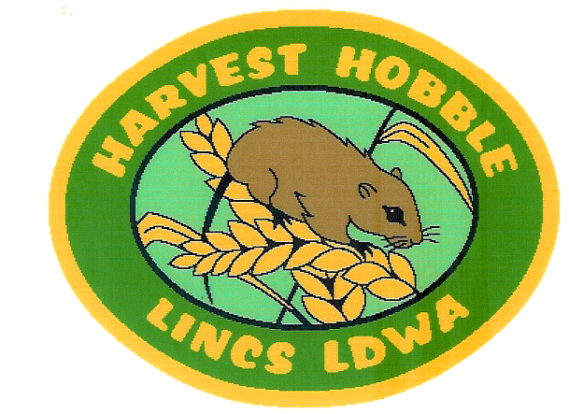

Lincolnshire LDWA Group
Harvest Hobble
Challenge

Saturday 19th September 2015

Walk or run
13 or 26 miles

Entrant Number

I wish to enter the Harvest Hobble Challenge

Name : ________________________________________________________

Address : _________________________________________________________
_____________________________________________________________________
_____________________________________________________________________

Telephone No: _____________________________________

E-mail address :_____________________________________
(for return of confirmation of entry , route details and results sheet)

Walker 13 mile

Walker 26 mile

Runner 13 mile

Runner 26 mile

Please delete as appropriate

Age _________

I enclose a cheque for the appropriate registration fee £………….

LDWA Membership No: -_______________________ (if appropriate )

I agree to obey the rules of this event :-

Signed : _____________________________________

Parent/guardian signature if under 18 : _____________________________________

Please fill in this sheet & return with appropriate payment by cheque
(made payable to Lincolnshire LDWA Group) to event secretary :
Terry Baines, Avalon , Ford Way, Goulceby
Louth LN11 9WD
Tel. 01507 343783
E-mail harvesthobble@btinternet.com

If no E-mail address given ,please enclose S.A.E. for return of confirmation of entry & route details (2 if results sheet required)

Harvest Hobble Challenge

DATE: Saturday 19th September 2015.

START & FINISH: Ludford Village Hall , Playing Field Lane
Ludford , Lincs LN8 6AJ
Grid Ref . TF197888 (Explorer 282)

OBJECT: To complete a 13 or 26 mile circuit on foot, mainly on footpaths and tracks, visiting a series of checkpoints and following a route description - within a 10 hour time limit.

START: Registration from 7.00 a.m.
Start 8.00 a.m. prompt

PARKING: Free parking at Ludford Village Hall adjacent to the start

REFRESHMENTS: Hot tea or coffee at start.
Please carry sufficient food and drink for the walk but cold drinks (please bring own mug ) with cakes , biscuits and savouries will be provided at all manned checkpoints .
Hot soup/roll and choice of sweet at finish.

SHOWERS Hot shower facilities are available

EQUIPMENT: You are advised to wear suitable footwear and clothing.
Please carry waterproofs, compass, whistle, survival bag and map.

MAPS: 1/25000: Lincolnshire Wolds North – Explorer 282.

AWARDS: A badge and certificate will be presented to all entrants who complete the event within the time limit .

ENTRY: Age limit – entrants under 16 yrs of age must be accompanied by
either a parent or guardian
Dogs are allowed if kept on a lead at all times

N.B.: - Due to limited space at the walk venue - entries are limited to 150

ENTRY FEE: LDWA Members £7.00

Non Members £8.00

Entries on the day £10.00 – but check availability with Terry Baines before the day

RULES

- You must obey the instructions of walk officials
- You must visit checkpoints in the correct order during their opening times
- You must make every effort to follow the prescribed route as laid out in the route description provided at the start of the walk
- You must respect and obey the Countryside Code
- Dogs are only allowed on the walk if they are kept on a lead and under control at all times . Please note that the playing field at event H.Q. is a “no dog” area
- Walk officials have the right to withdraw participants if their fitness to continue is in doubt
- Walk officials have the right to withdraw participants if they fail to reach a checkpoint before its scheduled closing time
- Walk tallies must be endorsed by a walk official at each checkpoint
- Walk tallies must be passed to a walk official at the end of the walk or when retiring from the walk at a checkpoint
- If you have to retire from the event please do so only at a checkpoint, ensure that you inform a walk official of your retirement and hand in your walk tally
- Please do not retire from the event without ensuring that the walk officials are informed!
- In the event of early retirement from the event, transport will be arranged for your return to the finish
- All participants take part in this event at their own risk
- The organisers of this event are not liable for accidents, thefts or loss of or damage to property (including whilst left in the car park).
- The route description issued for the guidance of participants must be used in conjunction with a compass and the appropriate Ordnance Survey Map

PLEASE DETACH THIS PAGE & RETAIN FOR REFERENCE

