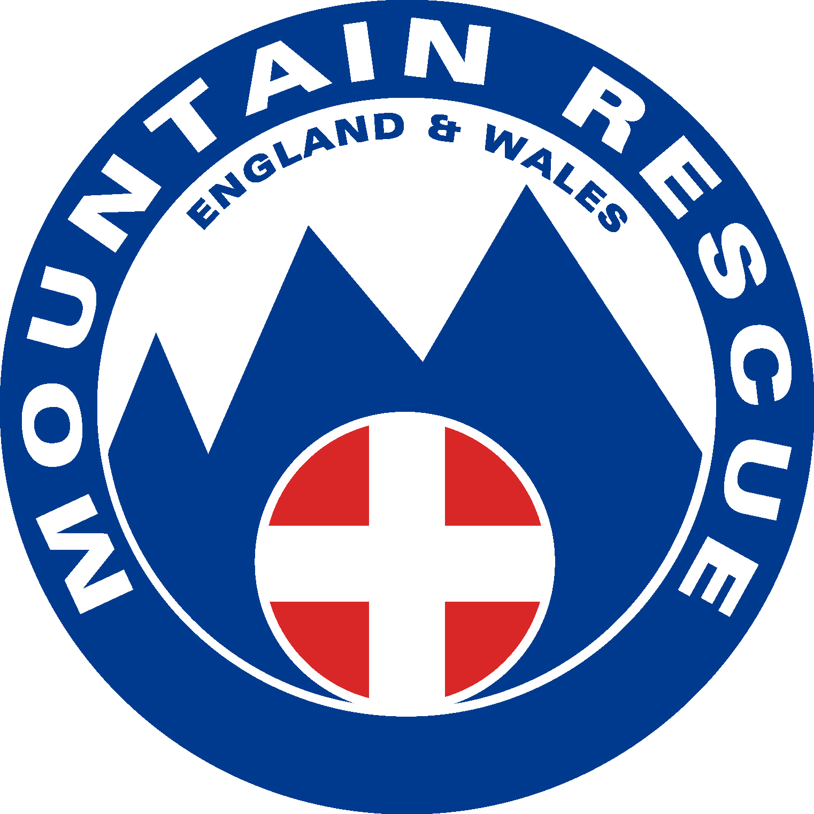 | Cleveland Survival  28th March 2015 | Entry No:
 | Cleveland Survival  28th March 2015 | I would like to walk with….
Return Completed Registration Forms to:
Event Secretary, 36 Cardinal Gardens, Darlington, County Durham, DL3 8SD

Surname |  |  | Height |  |  | Address
Forename |  |  | Hair Colour
Age |  |  | Sex
Tel No req |  |  | E-mail req.

A 26-mile (approx.) challenge through the heart of the North Yorkshire Moors
[Map reading and navigation skills required. See over leaf for a description of the event].
Limited Edition Survival Technical T-Shirt £10.00.
These will NOT be available if not pre-ordered. Please tick if required S M L XL

Walking Running Required B&B Information Vegetarian meal at finish
Have you taken part in any of our previous Survivals? Please mark the appropriate ones:
None | 1983 | 1984 | 1985 | 1986 | 1987 | 1988 | 1989 | 1990 | 1991 | 1992 | 1993 | 1994 | 1995 | 1996 | 1997 | 1998 | 1999 | 2000
(No event in 2001) |  |  | 2002 | 2003 | 2004 | 2005 | 2006 | 2007 | 2008 | 2009 | 2010 | 2011 | 2012 | 2013 | 2014
Please complete and sign this agreement

I, _______________________________of_____________________________, agree that no blame shall be attached to any member of Cleveland Mountain Rescue Team, to any of their helpers, or to the Cleveland Mountain Rescue Team itself, in respect of any injury, loss or damage I sustain.
Signed________________________________________ Date_______________

If you are under 18 years of age you must have your parent or guardian sign the following:
I,_______________________________ of_____________________________, agree that my child and I will both abide by the above agreement and I further declare that my child will be accompanied throughout the event by a parent or legal guardian of my child and has my permission to take part in the Cleveland Mountain Rescue Team’s ‘Cleveland Survival’ event and will be accompanied throughout the event by _________________________ who is over 18 years of age.

Signed___________________________ Date_______________ Relationship to child Mother/Father/Legal Guardian (delete as applicable)

Medical Information - STRICTLY CONFIDENTIAL
Please include anything that you think we should know - especially any drugs or medicine you need to take regularly.

NAME ________________________________________

DETAILS __________________________________________________________________________________

__________________________________________________________________________________
This section is for the team doctor’s information only.

Entry fee for the 2015 Cleveland Survival - £20.00. Please remember to include your cheque and two 9” x 7” stamped addressed envelopes when you return this form. An additional £10.00 will be required if you have ordered a Limited Edition Cleveland Survival T Shirt - mark the required size S/M/L/XL.
Cheques payable to: Cleveland Survival.
I wish to ‘gift aid’ the £20/£30. I am a standard Rate Tax Payer. Signed _________________.
For further details see over leaf or check the Team website at www.clevelandmrt.org.uk

Data Protection Act
Some or all of the information on this form may be entered into a computer for the purposes of administration, production of timings, placings and for the production and publication of the final results of the event. This information will only be used in accordance with the Data Protection Act.

